Following d/w LLP support team at RCOA they have confirmed that there is no way to complete Stage 2 equivalence form online retrospectively and advise uploading document with evidence mapped.

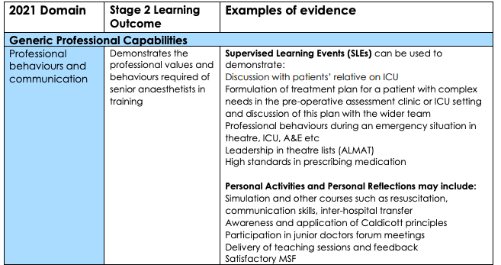

- Sim course faculty
- Run ROSTA (obstetric emergency anaesthesia simulation course)
  - 10/12/18, 07/06/19, 07/12/20, 17/05/21, 08/12/21
  - regional Obstetric Emergency...) https://lifelong.rcoa.ac.uk/formSubmission/4...
  - Organised and ran regional obstetric...) https://lifelong.rcoa.ac.uk/formSubmission/4...

- Faculty for APLS and ALS (including recent courses [APLS] 20-21/10/21, [ALS] 15/06/21, 22/09/21) https://lifelong.rcoa.ac.uk/formSubmission/4..., https://lifelong.rcoa.ac.uk/formSubmission/4...

- MSF
- MSF (Higher ICU 2020) https://lifelong.rcoa.ac.uk/msf/4...
- MSF (Anaesthetics 2021) https://lifelong.rcoa.ac.uk/msf/6...
- (Oct 2019-Sept 2020 maternity leave)
- MSF (Anaesthetics and ICU 2019 ST4) https://lifelong.rcoa.ac.uk/formSubmission/6...

- Consultant feedback
- Consultant Feedback Nov 2020 & May 2021 https://lifelong.rcoa.ac.uk/formSubmission/4...
- Feedback from Bucks 2019 (https://lifelong.rcoa.ac.uk/formSubmission/6...)

- Other
- OxDAT Wellbeing representative for trainees https://lifelong.rcoa.ac.uk/formSubmission/3...

SLE:
ICM I-CEX_(Led family discussion regarding...) https://lifelong.rcoa.ac.uk/formSubmission/3...
ALMAT_(Led two anaesthetic pre-operative...) https://lifelong.rcoa.ac.uk/formSubmission/4...
ALMAT_(Managed elective orthopaedic solo...) https://lifelong.rcoa.ac.uk/formSubmission/4...
ALMAT_(Management of elective day case...) https://lifelong.rcoa.ac.uk/formSubmission/3...
ALMAT_(Management of elective general...) https://lifelong.rcoa.ac.uk/formSubmission/3....
ALMAT_(Management of a busy emergency…) https://lifelong.rcoa.ac.uk/formSubmission/1....
ALMAT_(Managed emergency general surgery) https://lifelong.rcoa.ac.uk/formSubmission/1...
ALMAT_(Managed emergency theatre list...) https://lifelong.rcoa.ac.uk/formSubmission/1...

- Management of QI projects, obs course,
- Activity_(Led regional Obstetric Emergency...) https://lifelong.rcoa.ac.uk/formSubmission/4...
- Activity_(Organised and ran regional obstetric...) https://lifelong.rcoa.ac.uk/formSubmission/4...
- Activity_(Trainee wellbeing survey) https://lifelong.rcoa.ac.uk/formSubmission/3...

- Organised and ran SuppoRTT returning to training in the pandemic webinar
- Activity_(HEE-TV Supported return to training...) https://lifelong.rcoa.ac.uk/formSubmission/4...

- Rota allocation https://lifelong.rcoa.ac.uk/pdp/5606113/goal/5...

- OxDAT wellbeing rep (2020) https://lifelong.rcoa.ac.uk/formSubmission/3...
- OxDAT LTFT rep (2021-22) https://lifelong.rcoa.ac.uk/formSubmission/6...
- Activity_(Attendance at Anaesthetic school board) https://lifelong.rcoa.ac.uk/formSubmission/4...

- Local trainee rep for MKUH https://lifelong.rcoa.ac.uk/formSubmission/6...

- Courses
- Nuts and bolts in Health Service Management 8-9/9/21 https://lifelong.rcoa.ac.uk/formSubmission/6...

SLE:
- A-CEX_(Pre-operative assessment and family discussion…) https://lifelong.rcoa.ac.uk/formSubmission/14
- ALMAT_(Led two anaesthetic pre-operative...) https://lifelong.rcoa.ac.uk/formSubmission/4..

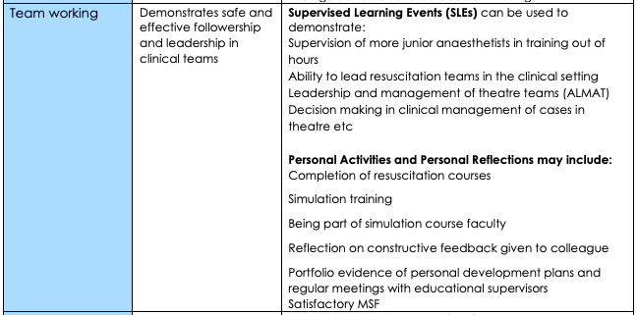

- Sim course faculty
- Continue to run ROSTA (obstetric emergency anaesthesia simulation course)
  - see CPD/teaching summary (https://lifelong.rcoa.ac.uk/formSubmission/6...)
  - 09/12/20 https://lifelong.rcoa.ac.uk/formSubmission/4...
  - 17/05/21 https://lifelong.rcoa.ac.uk/formSubmission/4...
- Faculty for APLS and ALS (including recent courses [APLS] 20-21/10/21, [ALS] 15/06/21, 22/09/21)

- MSF
- See page 1

- Consultant feedback
- See page 1

- ES meetings and PDPs
- Compliance with regular ES meetings and formulation of PDPs and goals (as represented on LLP or can be seen in satisfactory ARCP outcomes)

Teaching
- Activity_(Ultrasound guided cannulation course) https://lifelong.rcoa.ac.uk/formSubmission/4...
- Activity_(Viva practice as part of regional...) https://lifelong.rcoa.ac.uk/formSubmission/4...
- Activity_(Examiner at Oxford Final FRCA Viva...) https://lifelong.rcoa.ac.uk/formSubmission/1...

- Organised and ran SuppoRTT returning to training in the pandemic webinar
- Activity_(HEE-TV Supported return to training...) https://lifelong.rcoa.ac.uk/formSubmission/4...

SLE
- DOPS_(Teaching and supervision of novice) https://lifelong.rcoa.ac.uk/formSubmission/1...
- A-CEX_(Supervision of novice anaesthetic…) https://lifelong.rcoa.ac.uk/formSubmission/1...
- A-CEX_(Teaching medical student airway...) https://lifelong.rcoa.ac.uk/formSubmission/3...
- For ALMAT links see page 1
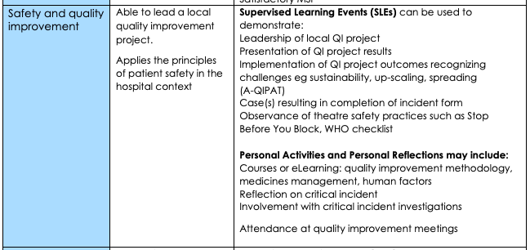

- Reflection on serious incident (2019) – https://lifelong.rcoa.ac.uk/formSubmission/2...

- Attendance at QI meetings (see attached CPD update documents for 2019 and 2021 ARCPs for further details)
- BHFT: 12/10/18 (0900-1300) 19/12/18 (1400-1700) 12/02/19 (1400-1730) 17/05/19 (0800-1300)
- MKUHT: 08/02/21, 26/05/21, 29/09/21,

- Leadership of QI projects
- Co-lead for professional compliance audit tool assessing trainee experience at MKUH
- MKUH lead for TVSOP sustainability QI project https://lifelong.rcoa.ac.uk/formSubmission/4...
- Lead for Obstetric QI project (Women’s experience of the provision of information regarding analgesia and anaesthesia in the antenatal and peripartum period.) https://lifelong.rcoa.ac.uk/formSubmission/6..
- MKUH Lead for data collection for cappuccini audit (https://lifelong.rcoa.ac.uk/formSubmission/3..
- Maternal haemorrhage Group – ST4 collaborative QI project: Activity_(Presentation of ST4 project at Bucks...) https://lifelong.rcoa.ac.uk/formSubmission/1..

- Presentation at regional event (macintosh)
- Poster presentation: maternal haemorrhage group. https://lifelong.rcoa.ac.uk/formSubmission/4..
- Oral presentation: trainee wellbeing survey. https://lifelong.rcoa.ac.uk/formSubmission/4..

- Safeguarding mandatory training up to date
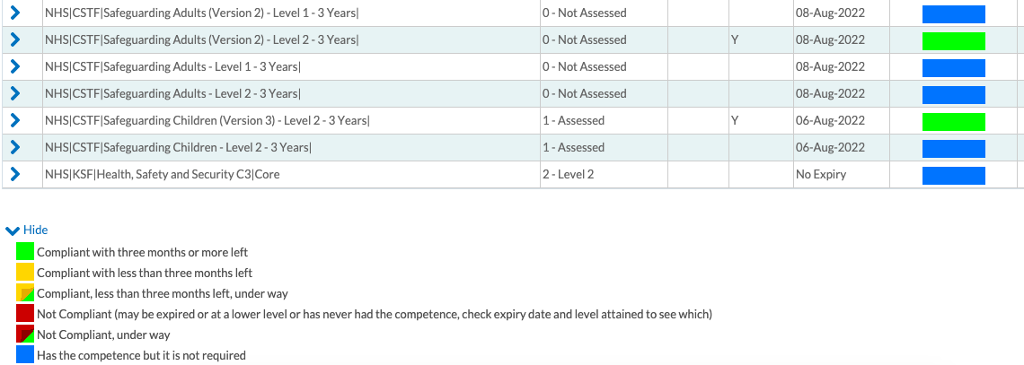

- Information governance mandatory training up to date

- MCA mandatory training up to date

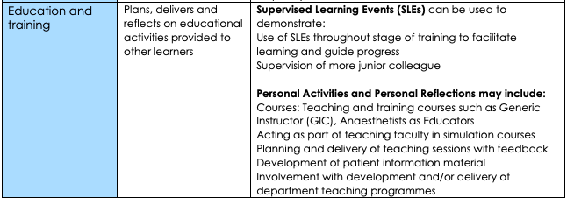

- Teaching logbook (part of CPD update documents https://lifelong.rcoa.ac.uk/formSubmission/6..
- Obs course (see page 1)
- APLS/ALS (see page 1) https://lifelong.rcoa.ac.uk/formSubmission/6...
- Attendance at simulation faculty development day https://lifelong.rcoa.ac.uk/formSubmission/1...

- SuppoRTT
Presentation at cross specialty return to training day: https://lifelong.rcoa.ac.uk/formSubmission/4..
Organised and ran SuppoRTT returning to training in the pandemic webinar https://lifelong.rcoa.ac.uk/formSubmission/4..

- Viva practice https://lifelong.rcoa.ac.uk/formSubmission/3..
- Examiner on viva course (oct 2019) https://lifelong.rcoa.ac.uk/formSubmission/1..

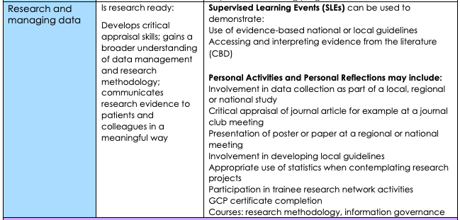

- MKUH Lead for data collection for cappuccini audit (https://lifelong.rcoa.ac.uk/formSubmission/3..
- GCP training Dec 2018
- Organising committee for Macintosh regional conference https://lifelong.rcoa.ac.uk/formSubmission/4..

- Presentation at regional event (macintosh)
https://lifelong.rcoa.ac.uk/formSubmission/4..
https://lifelong.rcoa.ac.uk/formSubmission/4..

MKUH lead for TVSOP sustainability QI project https://lifelong.rcoa.ac.uk/formSubmission/6..
Obstetric QI project https://lifelong.rcoa.ac.uk/formSubmission/6..
GAP ANALYSIS DOCUMENT RELEASED BY RCOA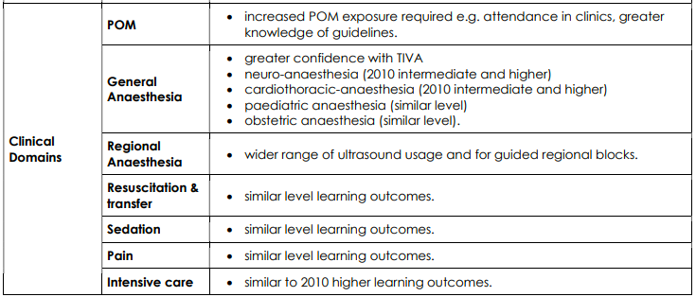

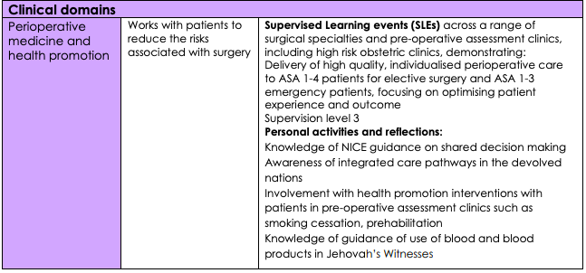

HIGHER Peri-op CUT https://lifelong.rcoa.ac.uk/formSubmission/4..
Intermediate Peri-op CUT https://lifelong.rcoa.ac.uk/formSubmission/6..
Log book from 2021 ARCP https://lifelong.rcoa.ac.uk/formSubmission/4..
Led obstetric high risk clinic 24/09/21 https://lifelong.rcoa.ac.uk/formSubmission/6..
Attended and participated in obstetric high risk clinic 17/11/21

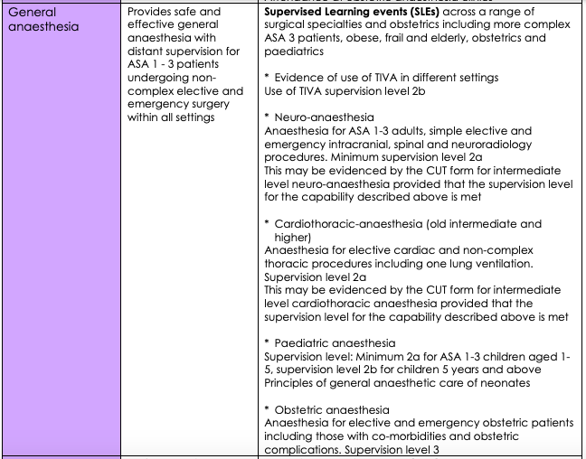

HIGHER General surgery CUT https://lifelong.rcoa.ac.uk/formSubmission/1..
Log book from 2021 ARCP https://lifelong.rcoa.ac.uk/formSubmission/4..

- TIVA in logbook
- Intermediate obs CUT https://lifelong.rcoa.ac.uk/formSubmission/6..
- Intermediate paeds CUT https://lifelong.rcoa.ac.uk/formSubmission/6..
- Intermediate general/gynae/urology CUT https://lifelong.rcoa.ac.uk/formSubmission/6..

Not achievable before rotation to OUH but understand some leniency:
- Neuro/Cardiac level 2a (I would be happy at this level however I don’t think my WBAs reflect this)
-

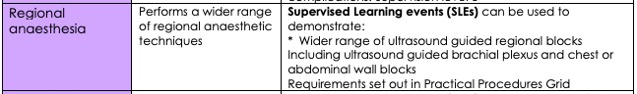

Intermediate Regional CUT https://lifelong.rcoa.ac.uk/formSubmission/6..
SLE US guided interscalene block (Dec 2020) https://lifelong.rcoa.ac.uk/formSubmission/4..
SLE US guided axillary block (Dec 2020) https://lifelong.rcoa.ac.uk/formSubmission/4..
SLE US guided supraclavicular block (May 2021) https://lifelong.rcoa.ac.uk/formSubmission/4..

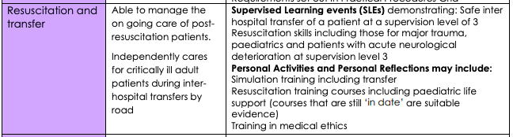

HIGHER Management of cardiac arrest CUT https://lifelong.rcoa.ac.uk/formSubmission/4..
Intermediate Management of cardiac arrest CUT https://lifelong.rcoa.ac.uk/formSubmission/6..
HIGHER Transfer CUT https://lifelong.rcoa.ac.uk/formSubmission/4..
APLS instructor https://lifelong.rcoa.ac.uk/formSubmission/4..
ALS instructorhttps://lifelong.rcoa.ac.uk/formSubmission/4..
(including recent courses [APLS] 20-21/10/21, [ALS] 15/06/21, 22/09/21)

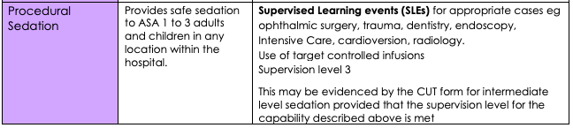

Intermediate sedation CUT https://lifelong.rcoa.ac.uk/formSubmission/6..
ALMAT – urology list with mix of GA and sedation. https://lifelong.rcoa.ac.uk/formSubmission/6..
ALMAT – cardioversion list with sedation https://lifelong.rcoa.ac.uk/formSubmission/6..

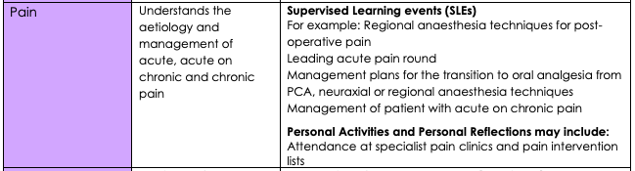

Intermediate Pain CUT https://lifelong.rcoa.ac.uk/formSubmission/6..

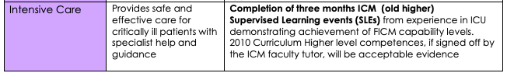

HIGHER ICM CUT https://lifelong.rcoa.ac.uk/formSubmission/4..
Intermediate ICM CUT https://lifelong.rcoa.ac.uk/formSubmission/6..
ICU logbook ST5 https://lifelong.rcoa.ac.uk/formSubmission/4..

